**GameCo 2017 Marketing Analysis Project Reflection**

**Context with Game Data 1**

**Visualization 1 2**

**Visualization 2 3**

**Visualization 3 4**

**Recommendation and Findings 5**

**Context with Game Data**

In order to find these insights, I began by making sure my data was cleaned of any duplicates, omitted data, as well as missing data. The first step I made was to create a pivot table that organized global sales by year and started to develop a line chart to monitor the progress. The second step was to then create “proportioned” categories of each region’s (NA, JP, and EU) sales in proportion to the global sales broken down by each year. This creates a line chart of all 3 regions and their respective proportion of the global market.

When analyzing the line graph, it was apparent to me that there was missing data in the beginning and end of the graph, signaling me to go back into my data and remove any rows that included 0 in any region to show a more accurate depiction of regional sales in proportion to global sales. After filtering the data, I retrieved the highest regional amount to breakdown the analysis further.

After summarizing and visualizing the data, there were a lot of interesting insights that I derived. The first interesting pattern I noticed is the relationship of when each region “peaked” and what path each region is currently going through. For example, the NA region had their highest proportion of the global market in 1984 with 66%, yet currently we see them as the 2nd highest region with a declining market since 2010. This tells me that the current games being released are not reaching the NA market as it used to. In contrast, the EU region is currently at its highest proportion of the global market at 38% despite starting much lower than the other two regions, meaning the market for the EU region is currently the highest it's ever been. I analyzed the data trends and created my insight in order to allocate marketing resources and maximize a return on investment.

**Visualization 1**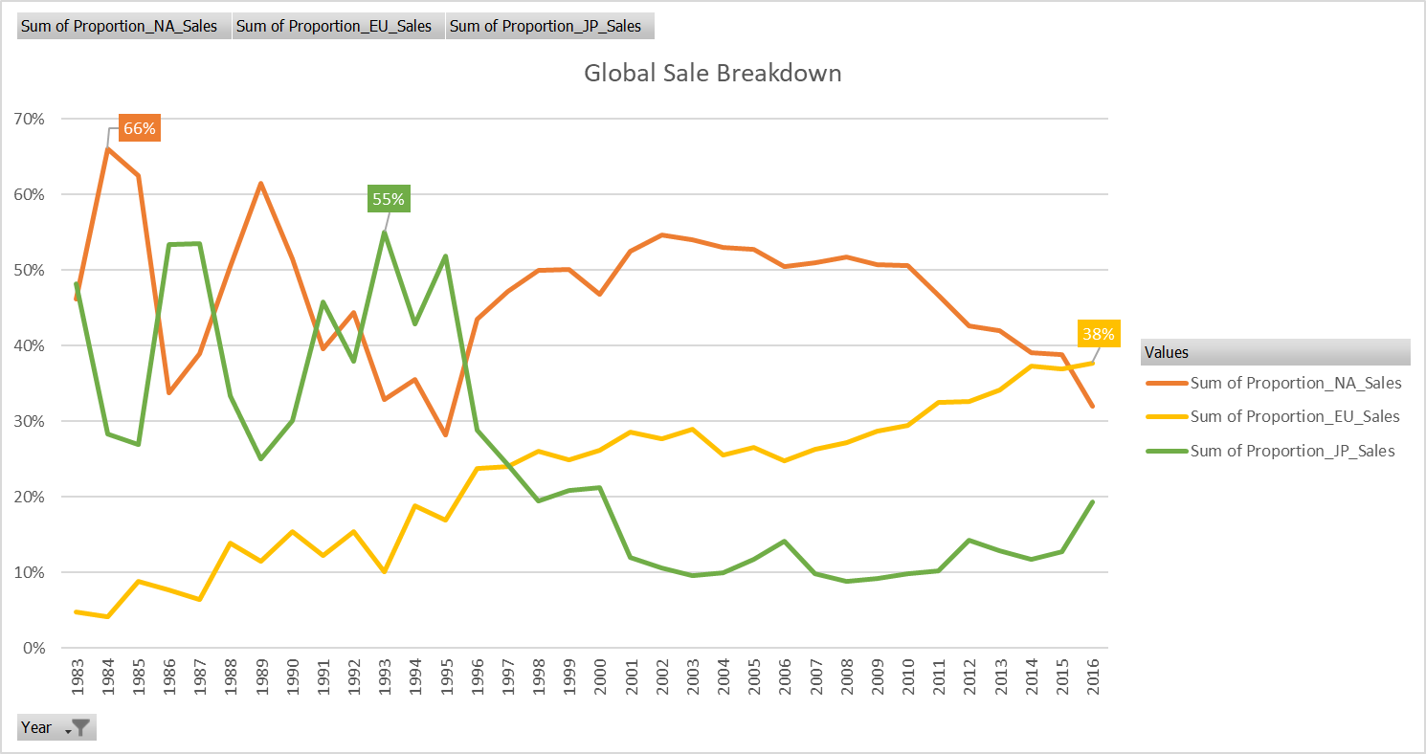

**Visualization 2**

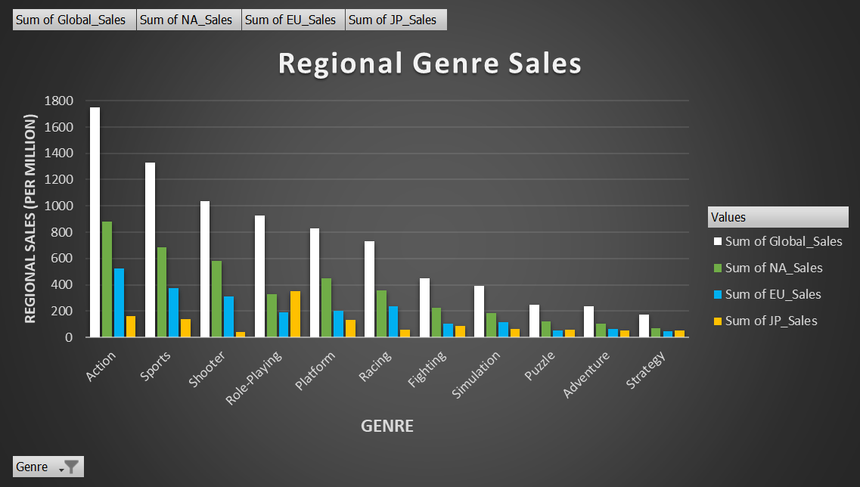

I thought of using this visual to follow the first line graph because I believed that the executives and marketing team would be interested in what genres have shown to return a profit, and I wanted to break it down based on each region to connect to the previous visual. For example, in the JP budget, there would be a higher emphasis on Role-Playing games compared to other genres. It differs from the previous visual from being a line graph to a column graph, but it still connects by showing the performance of each region. Connecting the trajectory of each region will help see which types of games the demographic enjoys within each region.

**Visualization 3**

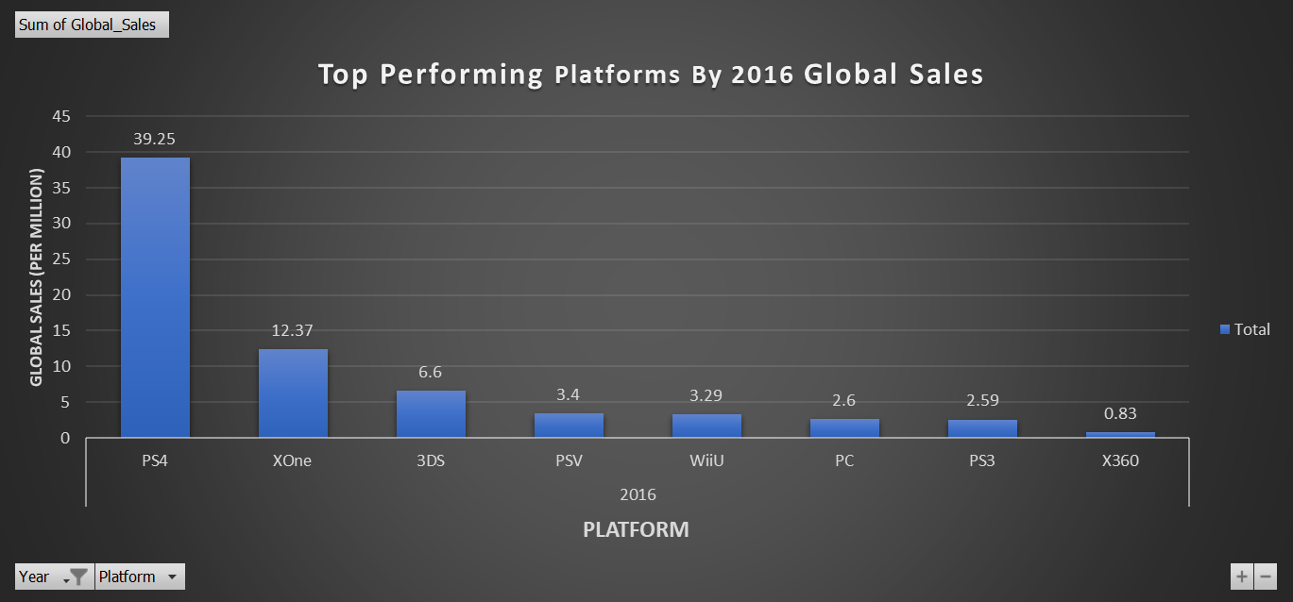

For this visual, I wanted to show a different comparison to provide the marketing team of which platforms and developers to be on the lookout for for next year's marketing budget. I feel like it tells the story of getting a better insight of not only knowing the trend of each region, but also within each region what is the console of choice and what type of games within each console connects with the demographic. Clearly now knowing that the PS4 is the majority console of choice, this helps the marketing team allocate assets towards PS4 games in the future. This visual is similar to the last visual of being a bar chart. However, it is different by not including the different regions as well as showing the values of each column.

**Recommendation and Findings**

| Based on the line charts and data analysis, several recommendations can be made regarding different regions. In the North American (NA) market, although it had a dominant position in the past, its proportion of global sales has significantly decreased compared to other regions. It is suggested to allocate fewer marketing funds to NA since its market share has been declining since 2015.  The European Union (EU) market, on the other hand, has shown steady interest in video games, and in 2016 it emerged as the highest proportioned market. Over time, it has demonstrated a strong customer base with a growing trend. Therefore, it is recommended to invest more marketing resources in the EU market.  Japan has historically been the lowest proportioned market in global sales, but recently it has been experiencing an upward trend. Although companies like Nintendo, Capcom, and Sony are based in Japan, their sales have dipped. However, the release of new games from these companies, such as the recently announced Mario games, could potentially impact the market positively. It is advised to monitor the trends and releases from Japanese game developers and create marketing campaigns accordingly for the Japanese (JP) market.  To summarize, the marketing department should consider allocating fewer funds to the declining NA market, invest more in the growing EU market, and keep an eye on new releases from Japanese game developers to leverage the potential of the JP market. |
| --- |